22EE450-Power Electronics

Assignment 1

2025-26 Even Semester
Due date:04.03.2026

10 x 4 = 40 Marks

- If the latching current in the given circuit is 100mA, then compute the minimum width of the gating pulse required to properly turn-on the SCR.
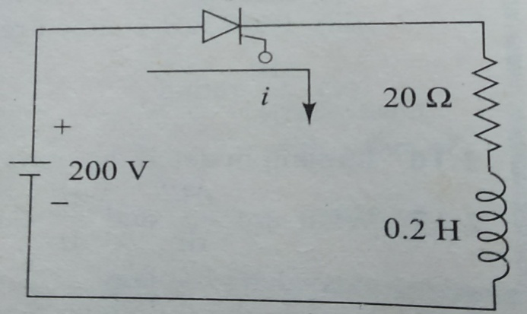
- The reverse biased junction capacitance of an SCR is 25 pico farads. The device can be turned ON if charging current flowing through the junction capacitor is 5mA. Calculate the dv/dt capability of the device.

- For the complementary commutation circuit, the DC source voltage is 120V and current through R & R_{L} = 20A. The turn-off time of both SCRs is 60µs. Calculate the value of commutating capacitance C for successful commutation.
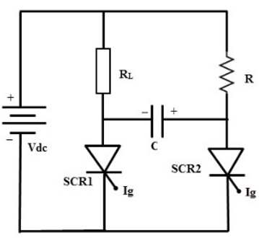

- The gate circuit of an SCR has a source voltage of 15V and the load line has a slope of 120V/Ampere. The minimum gate current to turn on the SCR is 25mA. Find,
- Gate-source resistance R_{s}
- Gate voltage and gate current for an average power dissipation of 0.4W.

Question 1-4:
Reference: 1. MD Singh & KB Khanchandani- Power Electronics, Tata Mc
Graw- Hill Publishing Company Ltd.
2. P.S.Bimbhra- Power Electronics, Khanna Publishers.

5)

6)

7)
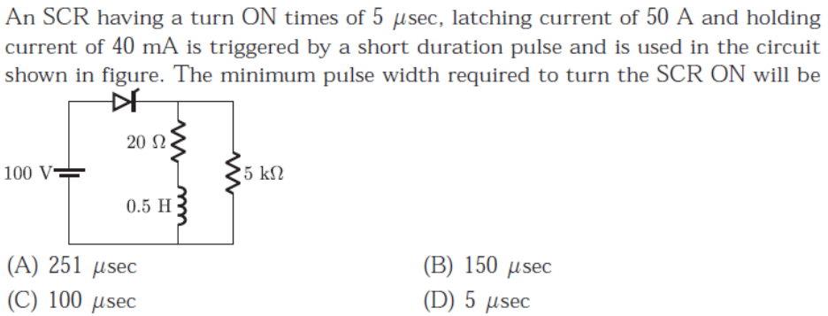

8)

9) 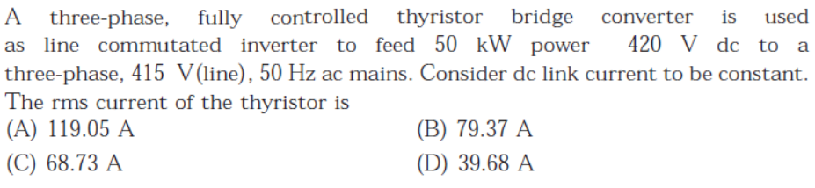

10)
